

COURSE PROJECT REPORT
Subject: SWD392

IELTSPhobic
IELTS Practice System (IPS)
A web-based platform with AI scoring for the 4 IELTS skills
Group: SE19B01_Group4
Version: 0.1 (Week 1)

– Da Nang, May 2026 –

Table of Contents
Record of Changes 3
I. Overview 4
I.1 Project Information 4
I.2 Project Team 4
II. Requirement Specification 4
II.1 Problem description 4
II.2 Major Features 4
II.3 Context Diagram 4
II.4 Nonfunction Requirements 5
II.5 Functional requirements 5
II.5.1 Actors 5
II.5.2 Use Cases 5
II.5.2 .1 Diagram(s) 5
II.5.2.2 Use case descriptions 6
II.5.3 Activity diagram 8
III. Analysis models. 9
III.1 Interaction diagrams 9
III.2 State diagram 10
IV. Design specification 11
IV.1 Integrated Communication Diagrams 11
IV.2 System High-Level Design 11
IV.3 Component and Package Diagram 11
IV.4 Class diagram 12
IV.5 Database Design 12
V. Implementation 13
V.1 Map architecture to the structure of the project 13
V.2 Map Class Diagram and Interaction Diagram to Code 13
V. Applying Alternative Architecture Patterns 13
V.1 Applying the service-oriented architecture 13
V.2 Applying Service Discovery Pattern in the service-oriented architecture 13

Record of Changes
Date | A*  M, D | In charge | Change Description
11/05/2026 | A | Nguyễn Nhật Quang | Initial version – Section I (Overview)
12/05/2026 | A | Hà Minh Quang | Section II.1 – Problem Description
13/05/2026 | A | Hà Minh Quang | Section II.2 – Major Features
14/05/2026 | A | Phạm Tấn Hải | Section II.3 – Context Diagram
15/05/2026 | A | Nguyễn Thanh Quân | Section II.4 – Nonfunctional Requirements
16/05/2026 | A | Phạm Hồng Quân | Section II.5.1 – Actors
16/05/2026 | A | Nguyễn Nhật Quang | Section II.5.2 – Use Case Diagrams
16/05/2026 | A | Phạm Hồng Quân | Section II.5.3 – Use Case List
17/05/2026 | M | Nguyễn Nhật Quang | Consolidated, reviewed, and finalized Week 1 v0.1
*A - Added M - Modified D - Deleted

I. Overview

I.1 Project Information
- Project name: IELTSPhobic – IELTS Practice System
- Project code: IPS
- Group name: SWD392-G3
- Software type: Web Application (Learner Site + Moderator Dashboard + Admin Dashboard)

I.2 Project Team
Full Name | Role | Email | Mobile
Nguyễn Phương Tâm | Lecturer | TamNP4@fe.edu.vn
Nguyễn Nhật Quang | Leader | nhatquang1223@gmail.com | 0905579811
Hà Minh Quang | Member | hmquang9805@gmail.com | 0817451859
Phạm Hồng Quân | Member | xuanwc321@gmailcom | 0702420470
Phạm Tấn Hải | Member | phamtanhai2912@gmail.com | 0775532651
Nguyễn Thanh Quân | Member | quannguyenthanh1309@gmail.com | 0787686893

II. Requirement Specification

II.1 Problem description
IELTSPhobic is a modern web-based platform that helps learners practice all four IELTS skills — Listening, Reading, Writing, and Speaking — through realistic computer-based simulations. The system integrates AI scoring (powered by OpenAI) for Writing and Speaking, giving instant feedback and improvement suggestions.
Beyond test practice, IELTSPhobic includes a built-in dictionary, smart flashcards for vocabulary building, and a community forum where learners can discuss questions, share tips, and post text, images, or audio samples. The platform supports secure login via email or Google, and stores all results for progress tracking. VIP users gain full access to official-style tests, unlimited flashcards, detailed AI reports, and advanced study insights. Moderators handle forum content and user suspensions; Admins manage tests, premium plans, and statistics.
The system replaces fragmented manual workflows (paper tests, separate dictionary apps, scattered learning materials) with a single integrated platform. Release 1.0 covers core practice, AI feedback, forum, and Stripe-based VIP payment. Future releases will add a mobile app and a multi-center deployment.

II.2 Major Features
Features are grouped into four feature areas:
Authentication & Account (FE-A-xx)
• FE-A-01: Register (email/password) and Register with Google.
• FE-A-02: Login (email/password), Login with Google, Forgot Password, Logout.
• FE-A-03: Update Profile & Change Password.
• FE-A-04: View VIP Plans, Upgrade to VIP via Stripe payment gateway.
Test Practice & AI Feedback (FE-T-xx)
• FE-T-05: View test list by skill (Listening / Reading / Writing / Speaking).
• FE-T-06: Start practice for Listening, Reading, Writing, Speaking with a timer.
• FE-T-07: Answer questions, record audio (Speaking), autosave every 5 seconds.
• FE-T-08: Submit test (full/partial), receive result overview and band score.
• FE-T-09: Get answer explanation (Reading/Listening), transcript (Listening/Speaking).
• FE-T-10: Get AI analysis and feedback for Writing and Speaking (VIP-only).
• FE-T-11: View test history, track progress with dashboard and charts.
Dictionary, Vocabulary & Forum (FE-L-xx)
• FE-L-12: Built-in dictionary search; manage vocabulary groups (add/edit/delete).
• FE-L-13: Create and review flashcards from saved words.
• FE-L-14: Forum – view, search, create/edit/delete own post (text, image, audio).
• FE-L-15: Comment, reply, like/unlike, pin/unpin, hide/unhide post.
• FE-L-16: Report inappropriate forum content.
Moderation & Administration (FE-M-xx)
• FE-M-17: Moderator – view user activity, suspend/activate user, manage forum posts/comments.
• FE-M-18: Moderator – handle reports from users, send notifications.
• FE-M-19: Admin – manage Listening/Reading/Writing/Speaking tests (add/edit/delete).
• FE-M-20: Admin – view user statistics, test activity.
• FE-M-21: Admin – assign roles & permissions, manage premium plans.
• FE-M-22: Admin – view and export transactions (CSV/Invoice).

II.3 Context Diagram
The context diagram shows IELTSPhobic as a black box and identifies external entities interacting with it: 4 external users (Guest, Learner, Moderator, Admin) and 5 external systems (Google Authentication, Stripe Payment Gateway, OpenAI API for AI scoring, Cloudinary for file storage, Email/Notification Service).
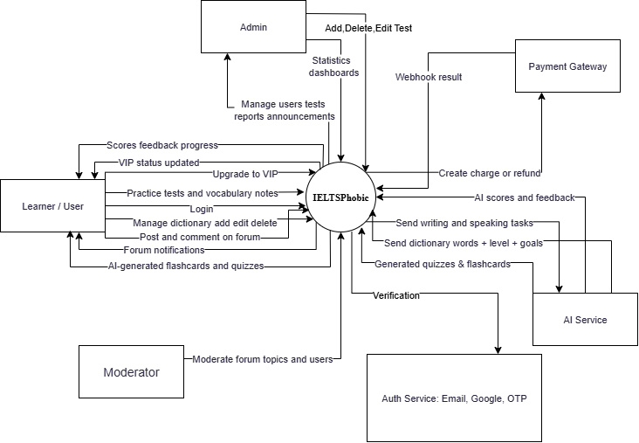
Figure 1: Context Diagram

II.4 Nonfunctional requirements
# | Feature | System Function | Description
1 | NF-01 | Maintainability | Clear traceability between Controller, Service, and Repository layers; modular code organized by feature module; comprehensive documentation to support efficient maintenance and updates.
2 | NF-02 | Usability | Find a test and complete a practice attempt within 5 minutes; error rate < 5% for key tasks; user satisfaction score ≥ 85%. Auto-save every 5 seconds prevents data loss on disconnect.
3 | NF-03 | Portability | Compatible with latest Chrome, Firefox, Safari, Edge. Responsive design from 320px to 1920px (React 18 frontend). Future mobile app planned.
4 | NF-04 | Performance | Page load < 4 seconds for 95% of users; supports at least 1,000 concurrent users; Listening audio preloads; server-side timer remains accurate after page refresh.
5 | NF-05 | Reusability | Same business logic reusable across the web Learner Site, Moderator Dashboard, Admin Dashboard, and a future mobile app (alternative architecture to be designed later).
6 | NF-06 | Scalability | Support horizontal and vertical scaling; capable of handling growing transactions when expanding to a multi-center deployment.
7 | NF-07 | Security | Passwords hashed with salt before storage; HTTPS/TLS in transit; Role-Based Access Control (RBAC) with three roles (Learner, Moderator, Admin); account verification via Email OTP; all admin actions audit-logged.
8 | NF-08 | Availability & Reliability | 99.9% uptime; automatic failover; daily database backups; recovery within 30 minutes after a crash; ACID-compliant database.

II.5 Functional requirements

II.5.1 Actors
The system has 5 actors — 4 external users and 1 external system (Payment Gateway).
# | Actor | Description
1 | Guest | A user who does not have an account or is not logged in; can register, view test lists, and browse forum content.
2 | Learner (User) | A logged-in learner who can take tests, save results, use the dictionary, manage vocabulary, participate in the forum, and send feedback.
3 | Moderator | System administrator responsible for managing tests, generating reports, assigning roles, viewing payments, and monitoring user activities.
4 | Administrator | Moderator who can handle reports/complaints, manage forum content, suspend/activate user accounts, and send system-wide notifications.
5 | Payment Gateway (Stripe) | Processes payment, sends webhook events, confirms success/failure

II.5.2 Use Cases

II.5.2 .1 Diagram(s)
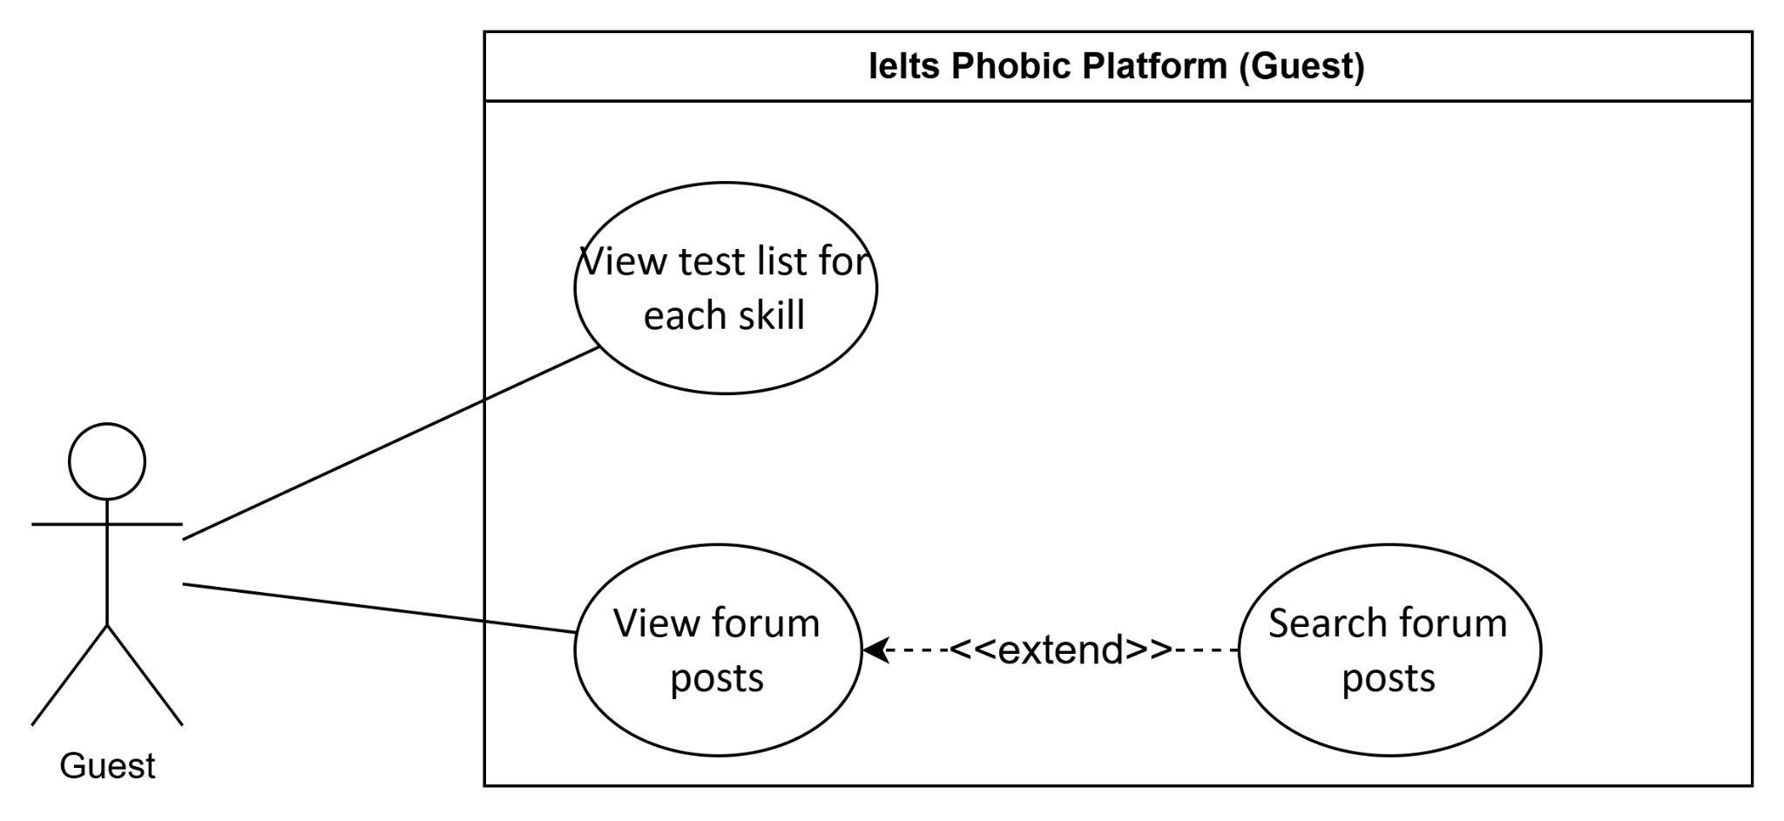
Figure 2:Use case diagram for Guest
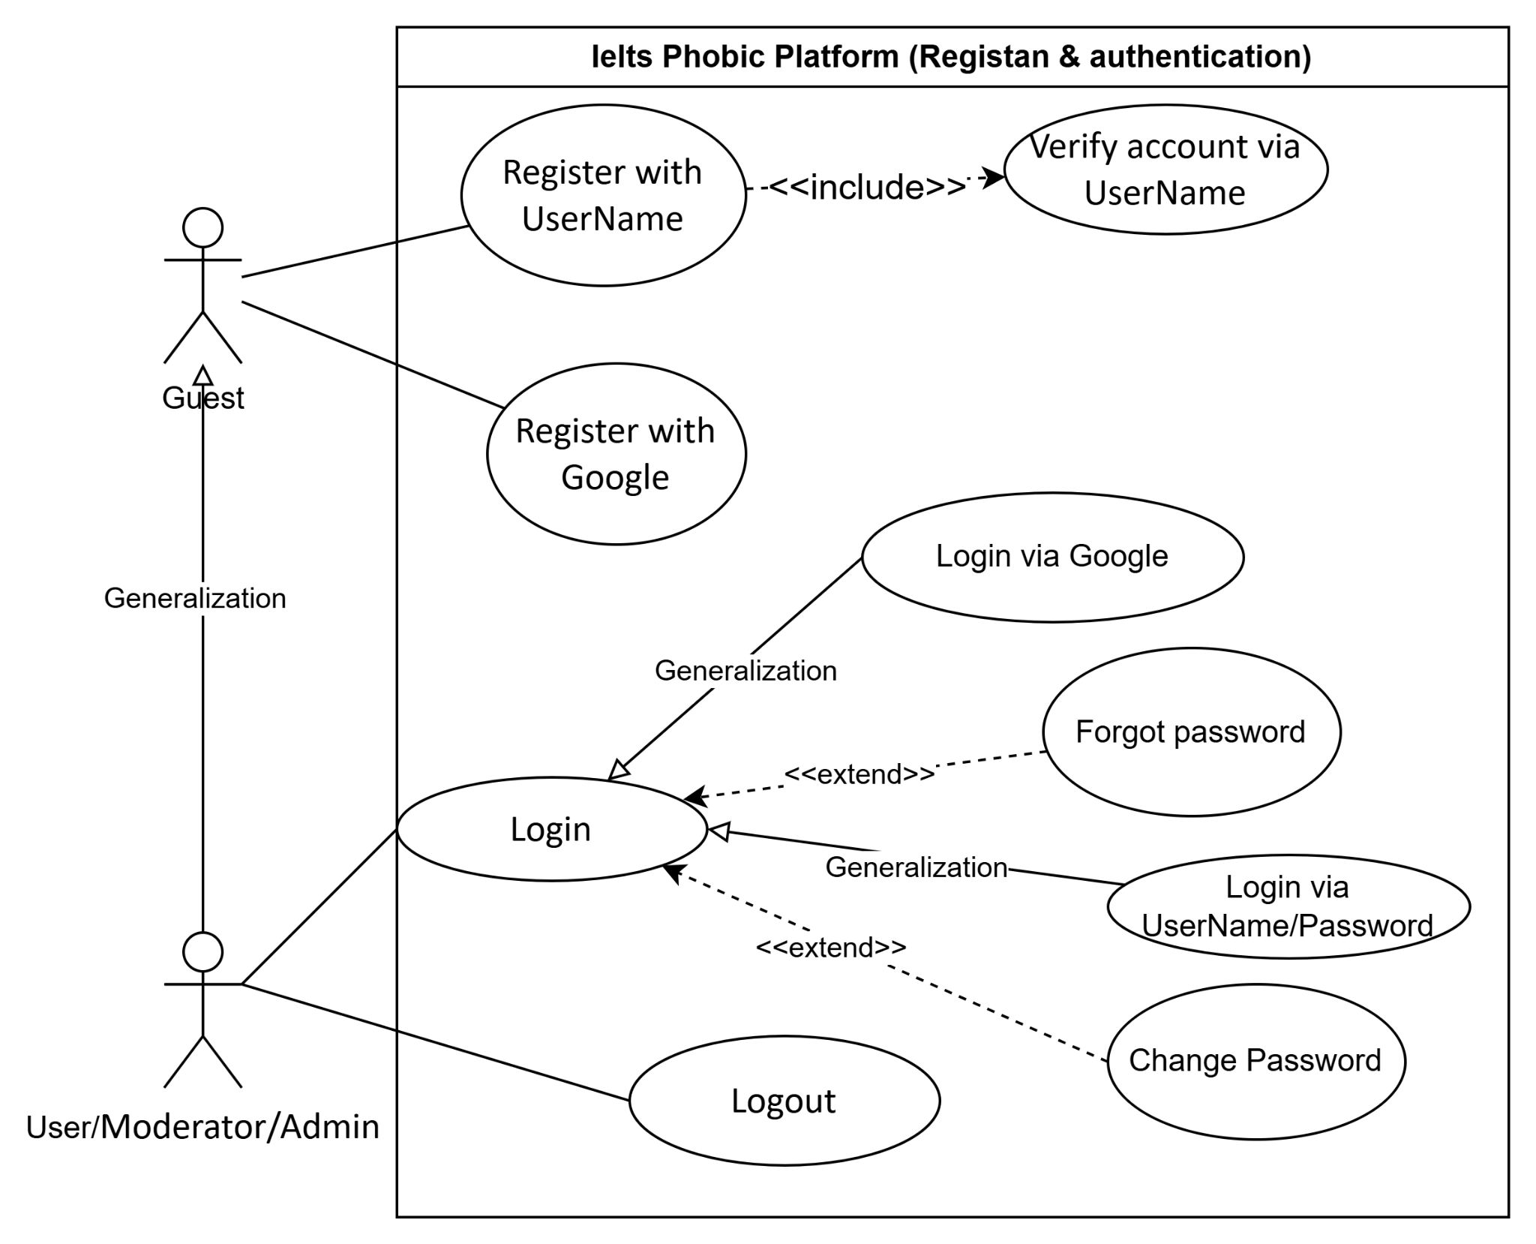
Figure 3:Use Case Authentication
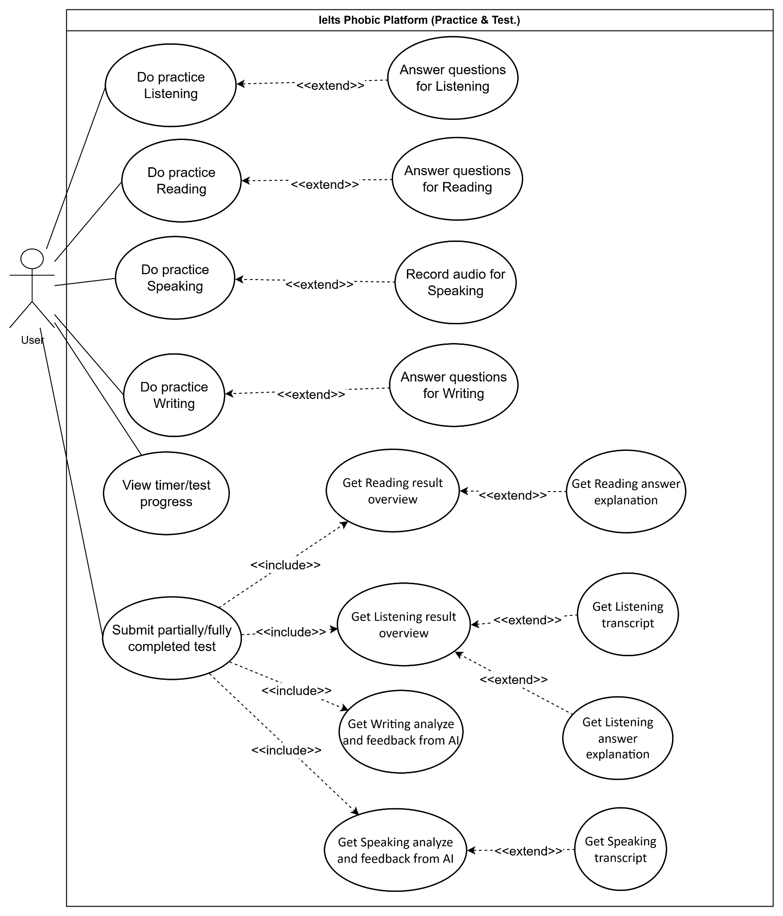
Figure 4:Use Case Practice and Test
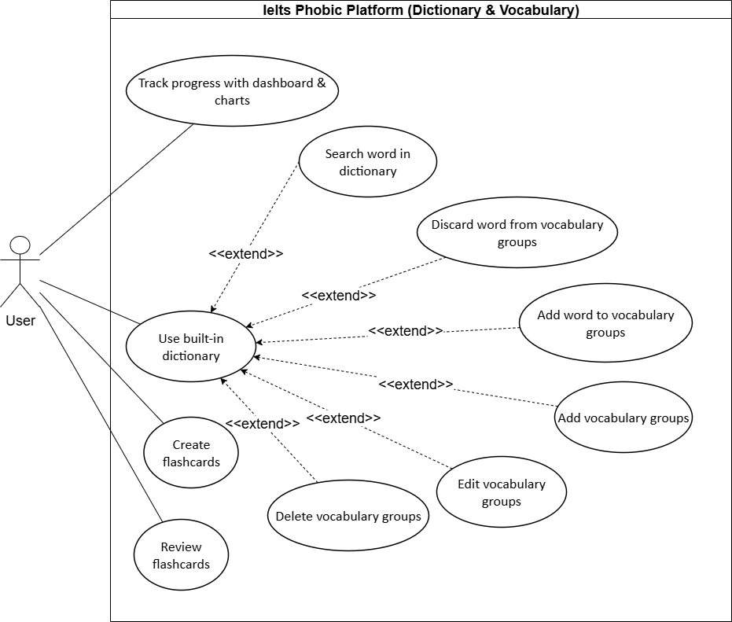
Figure 5:Use Case Dictionary and Vocabulary
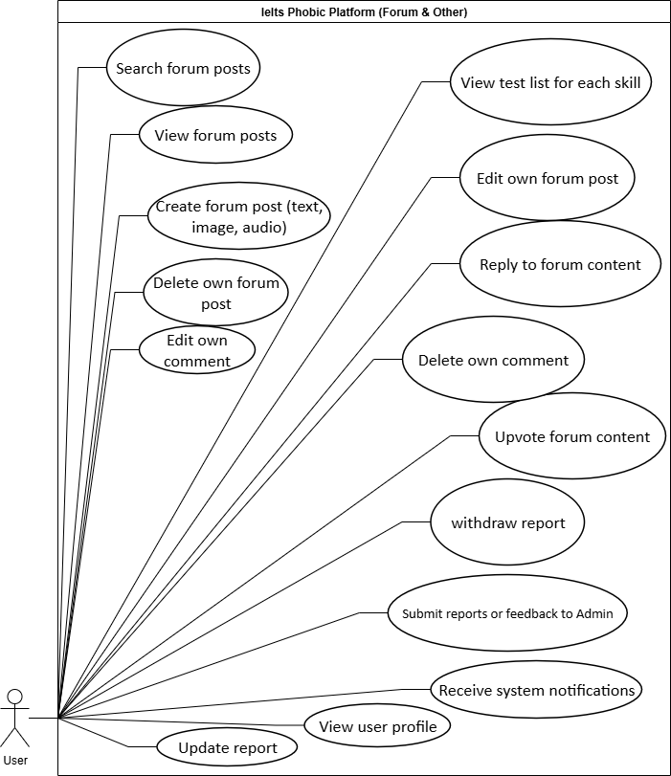
Figure 6:Use Case Forum & Other
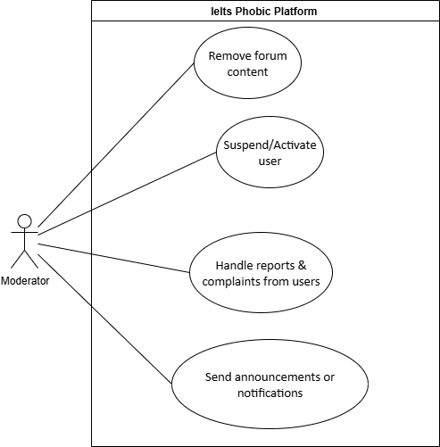
Figure 7:Use Case For Moderator
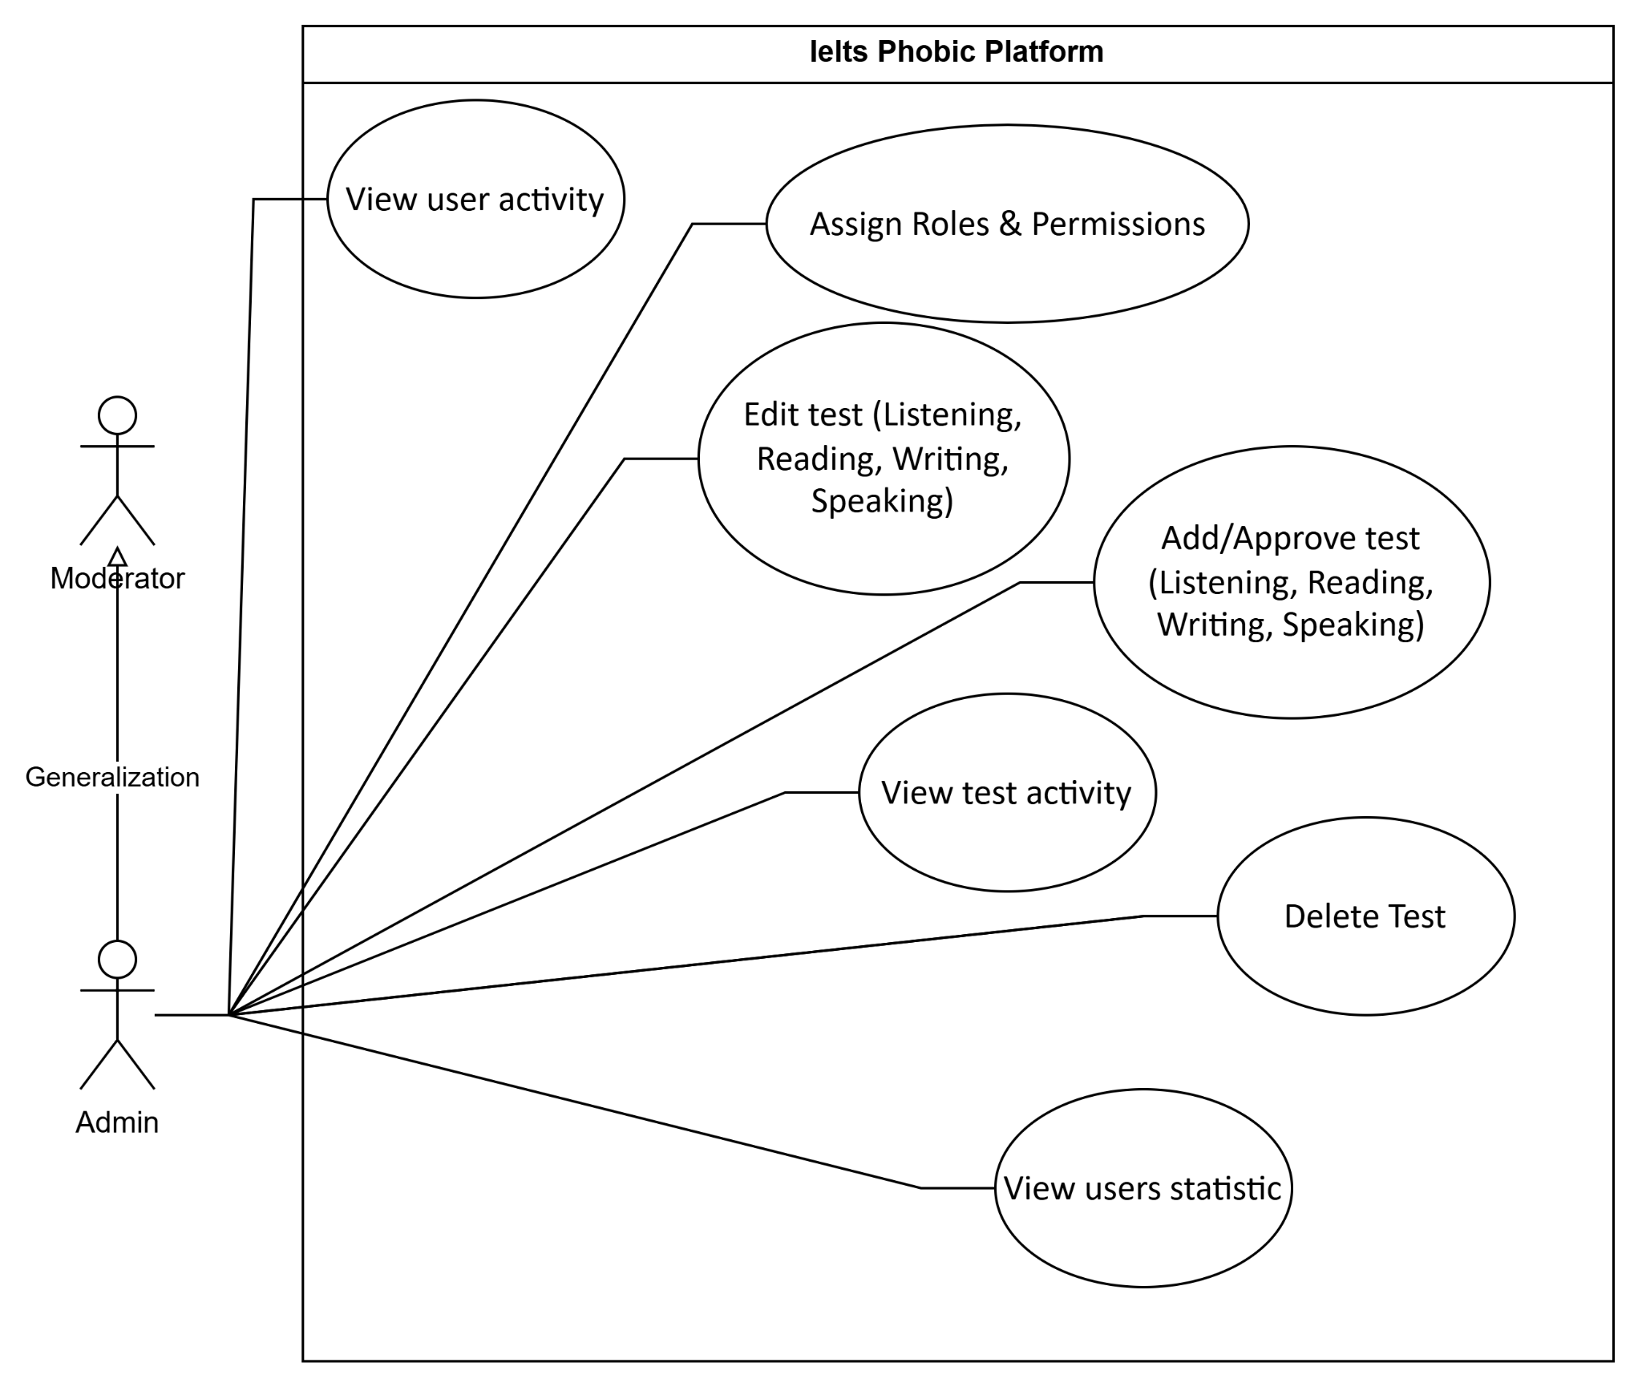
Figure8 :Use Case For Admin
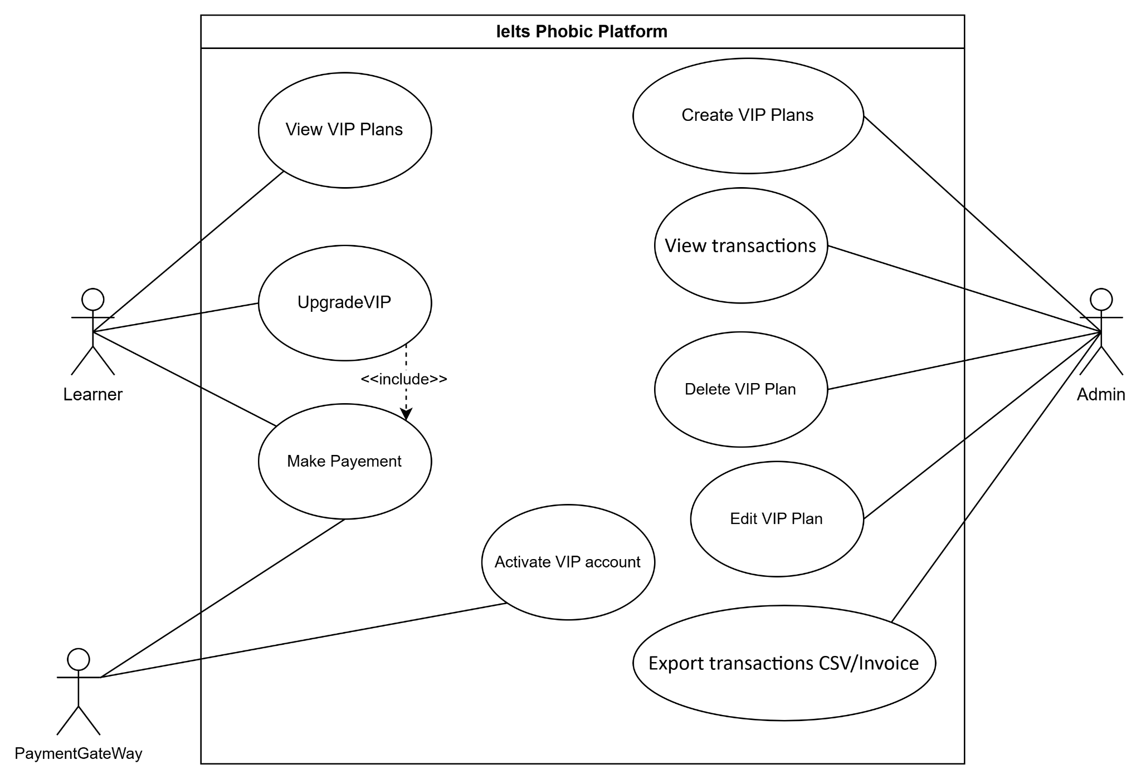
Figure9 :Use Case For VipPlan

II.5.2.2 Use case descriptions
ID | Use Case | Actors | Use Case Description
UC-01 | Register with Email and Password | Guest | The guest creates a new account by filling in registration details and confirming submission.
UC-02 | Register with Google | Guest | The guest creates a new account quickly using their Google credentials.
UC-03 | View VIP Plans | User | The customer views a list of available VIP plans, including their prices, durations, and benefits.
UC-04 | Login | Guest | The student logs into the system using valid credentials to access features.
UC-05 | Login via Google | Guest | The guest logs into the system quickly and securely using their Google credentials.
UC-06 | Forgot password | Guest | The guest resets their password by requesting a reset link and creating a new password.
UC-07 | Logout | User | The student ends the session and securely logs out.
UC-08 | Update profile & password | User | The student updates personal information and changes their password to maintain account security.
UC-09 | Upgrade to VIP account | User,  Payment  Gateway | The student selects a VIP plan and proceeds with payment through the integrated Stripe Gateway. Upon successful payment, Stripe sends a webhook to the backend, which automatically records the transaction and upgrades the user to VIP status without admin approval.
UC-10 | View test list for each skill | Guest | The guest views available test lists for Listening, Reading, Writing, and Speaking.
UC-11 | Start practice Listening | User | The student begins a Listening practice session.
UC-12 | Start practice Reading | User | The student begins a Reading practice session.
UC-13 | Start practice Writing | User | The student begins a Writing practice session.
UC-14 | Start practice Speaking | User | The student begins a Speaking practice session.
UC-15 | Answer questions for Listening | User | The student answers Listening test questions in multiple-choice or short-answer format.
UC-16 | Answer questions for Reading | User | The student answers Reading test questions in multiple-choice or short-answer format.
UC-17 | Answer questions for Writing | User | The student writes responses for Writing tasks.
UC-18 | Record audio for Speaking | User | The student records spoken answers for Speaking tasks.
UC-19 | View timer/test progress | User | The student tracks time remaining and progress during a test.
UC-20 | Submit partially/fully completed test | User | The student submits test responses, either complete or partial.
UC-21 | Get Reading result overview | User | The student views overall Reading scores and performance.
UC-22 | Get Reading answer explanation | User | The student reviews explanations for Reading answers.
UC-23 | Get Listening result overview | User | The student views overall Listening scores and performance.
UC-24 | Get Listening transcript | User | The student accesses transcripts of Listening test audio.
UC-25 | Get Listening answer explanation | User | The student reviews explanations for Listening answers.
UC-26 | Get Writing analyze and feedback from AI | User | The system provides automated analysis and feedback on Writing responses.
UC-27 | Get Speaking analyze and feedback from AI | User | The system provides automated analysis and feedback on Speaking responses.
UC-28 | Get Speaking transcript | User | The system generates transcripts of the student’s Speaking responses.
UC-29 | Use built-in dictionary | User | The student looks up word meanings, pronunciation, and usage.
UC-30 | Search word in dictionary | User | The student searches for a specific word in the dictionary.
UC-31 | Add word to vocabulary groups | User | The student saves a word into a selected vocabulary group.
UC-32 | Discard word from vocabulary groups | User | The student removes a word from a vocabulary group.
UC-33 | Add vocabulary groups | User | The student creates a new vocabulary group for organizing words.
UC-34 | Edit vocabulary groups | User | The student renames or modifies vocabulary groups.
UC-35 | Delete vocabulary groups | User | The student deletes a vocabulary group permanently.
UC-36 | Create flashcards | User | The student creates flashcards for study and review.
UC-37 | Review flashcards | User | The student practices vocabulary using flashcards.
UC-38 | Review test history | User | The student reviews past test attempts for improvement.
UC-39 | Track progress with dashboard & charts | User | The student monitors learning progress using performance charts.
UC-40 | Receive system notifications | User | The student receives system alerts such as reminders or updates.
UC-41 | Submit reports or feedback | User | The student sends problem reports or feedback to administrators.
UC-42 | View user profile | User | The student views personal or public user profile details.
UC-43 | View forum posts | Guest | The guest browses posts in the forum.
UC-44 | Search forum posts | Guest | The guest searches forum posts using tags.
UC-45 | Create forum post (text, image, audio) | User | The student creates and shares a post in the forum.
UC-46 | Edit own forum post | User | The student edits content of their own forum post.
UC-47 | Delete own forum post | User | The student deletes their own forum post.
UC-48 | Reply to forum content | User | The student adds comments or replies to forum posts or comments.
UC-49 | Edit own comment | User | The student edits their own comment in the forum.
UC-50 | Delete own comment | User | The student deletes their own comment in the forum.
UC-51 | Like/Unlike forum content | User | The student upvotes posts or comments to show support.
UC-52 | Pin/Unpin forum post | User | The students can pin post to the top of the forum or unpin that.
UC-53 | Hide/Unhide forum post | User | The students can hide the post they don't like to closed’s post list or unhide that
UC-54 | View user activity | Admin | The admin reviews user activities and engagement logs.
UC-55 | Suspend/Activate user | Moderator | The moderator disables or re-enables a user account.
UC-56 | Assign Roles & Permissions | Admin | The admin grants or modifies user roles and access permissions.
UC-57 | Add Listening test | Admin | The admin creates or approves new Listening tests.
UC-58 | Edit Listening test | Admin | The admin updates Listening test content.
UC-59 | Add Reading test | Admin | The admin creates or approves new Reading tests.
UC-60 | Edit Reading test | Admin | The admin updates Reading test content.
UC-61 | Add Writing test | Admin | The admin creates or approves new Writing tests.
UC-62 | Edit Writing test | Admin | The admin updates Writing test content.
UC-63 | Add Speaking test | Admin | The admin creates or approves new Speaking tests.
UC-64 | Edit Speaking test | Admin | The admin updates Speaking test content.
UC-65 | Delete Test | Admin | The admin removes a test from the system.
UC-66 | View test activity | Admin | The admin monitors test usage and attempts by users.
UC-67 | View users statistic | Admin | The admin views statistical reports of user activity and performance.
UC-68 | Handle reports & complaints from users | Moderator | The moderator reviews and resolves complaints or reports submitted by users.
UC-69 | Send announcements or notifications | Moderator | The moderator broadcasts announcements or system-wide notifications.
UC-70 | Manage Premium plans & payments | Admin,  Payment Gateway | The admin manages premium plan configurations and synchronizes them with Stripe Products and Prices. All payments and subscriptions are handled automatically by Stripe; the system receives real-time webhook notifications for successful or failed payments.
UC-71 | View transactions | Admin | The admin views all transactions processed through Stripe, including payment status, timestamps, and associated user information. Manual approval is not required since payments are verified by Stripe.
UC-72 | Export transactions CSV/Invoice | Admin | The admin exports transaction records into CSV or invoice format.

